**PL/SQL**

Q1: Write a PL/SQL program to find the factorial of a given number.

declare

fact number:=1;

n number:=&n;

begin

for i in 2..n

loop

fact:=fact*i;

end loop;

dbms_output.put_line(chr(0)||'factorial of'||n||'is:'||fact);

end;

/

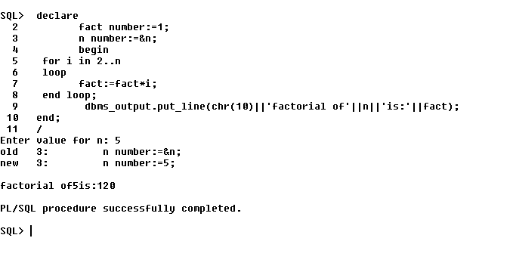

Q2: Write a PL/SQL program to check whether the given no is prime or not

declare

n number:=&n;

i number:=2;

f number:=1;

begin

for i in 2..n/2

loop

if n mod i=0

then

f:=0;

exit;

end if;

end loop;

if f=1

then

dbms_output.put_line(n||' is prime');

else

dbms_output.put_line(n||' is not a prime');

end if;

end;

/

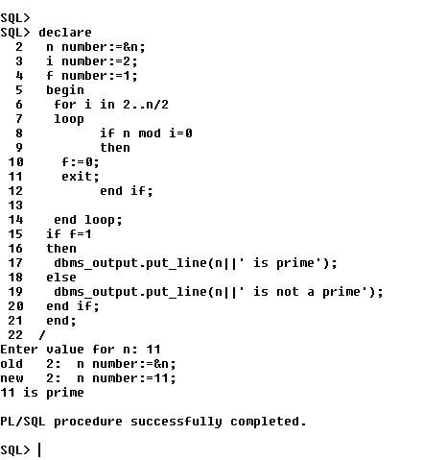

**Functions**

1. Write a PL/SQL program to Check whether a number is Armstrong or not using functions.

-- Armstrong program using function.....

create or replace function armstrong(x in number)

return number as

powr number;

num number;

a number;

len number;

begin

num:=x;

powr:=0;

len:=length(to_char(num));

for i in 1..len

loop

a:=mod(num,10);

powr:= powr+power(a,len);

num:=trunc(num/10);

end loop;

return powr;

end;

/

set serveroutput on;

declare

x number;

value number;

begin

value:=&value;

x:=armstrong(value);

if x=value

then

dbms_output.put_line(chr(10)||' Armstrong.....');

else

dbms_output.put_line(chr(10)||' Not Armstrong....');

end if;

end;

/

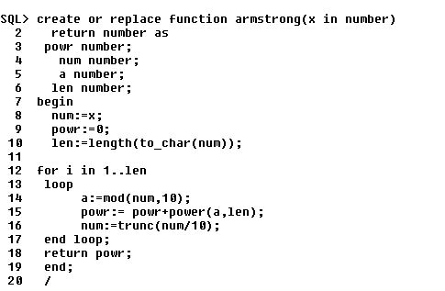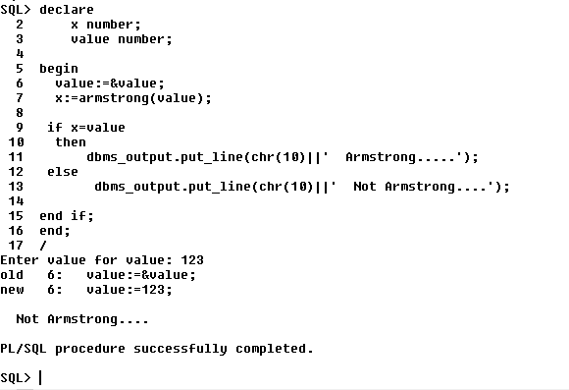

1. Create table that contains itemid,item_name & price of several items sold in a grocery shop, Using functions retrieve the item name & price from table when itemid is given as input.

SQL> create table item(item_id varchar(10), item_name varchar(20), price int);

Table created.

SQL> insert into item values ('&item_id','&item_name',&price);

Enter value for item_id: p101

Enter value for item_name: brush

Enter value for price: 80

old 1: insert into item values ('&item_id','&item_name',&price)

new 1: insert into item values ('p101','brush',80)

1 row created.

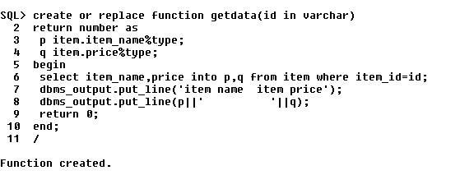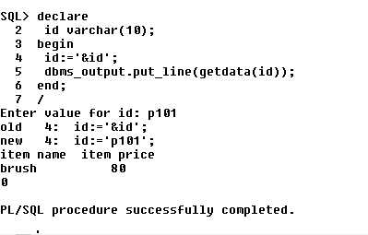

1. Write a PL/SQL function called POW that takes two numbers as argument and return the value of the first number raised to the power of the second .